**Read Me**

I use Project no 1 , out of listed 10 projects . <https://github.com/ruanyf/simple-bash-scripts>

* I forked this repo and it got copied to my account .

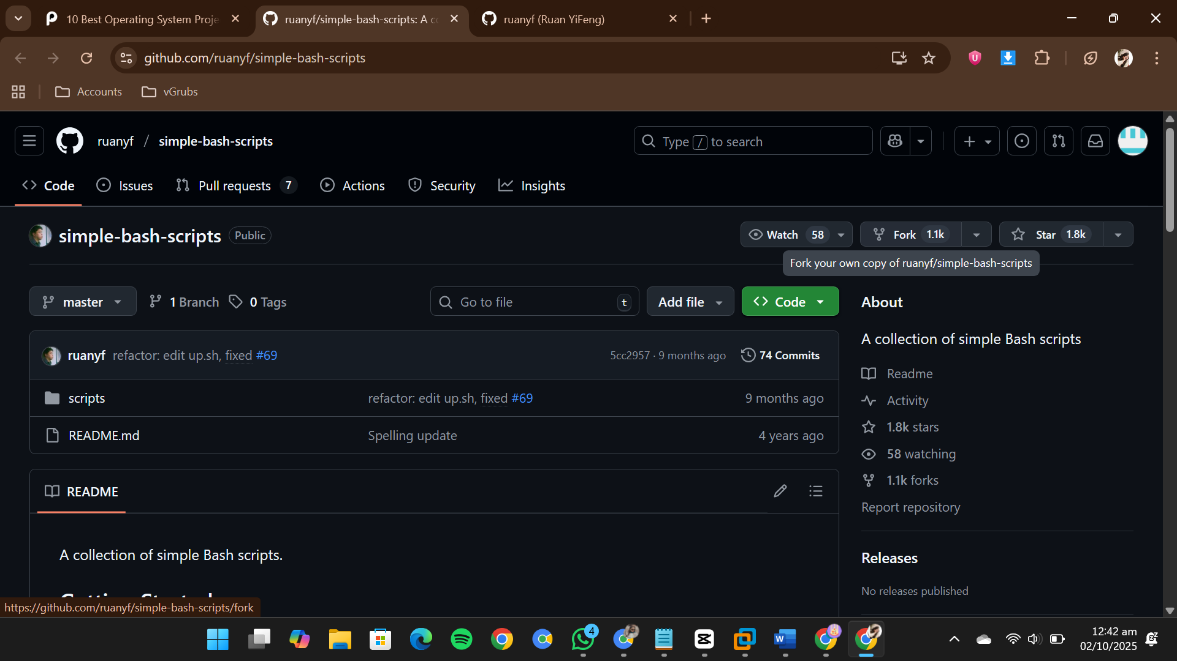

* Now , the repository was cloned to my account.

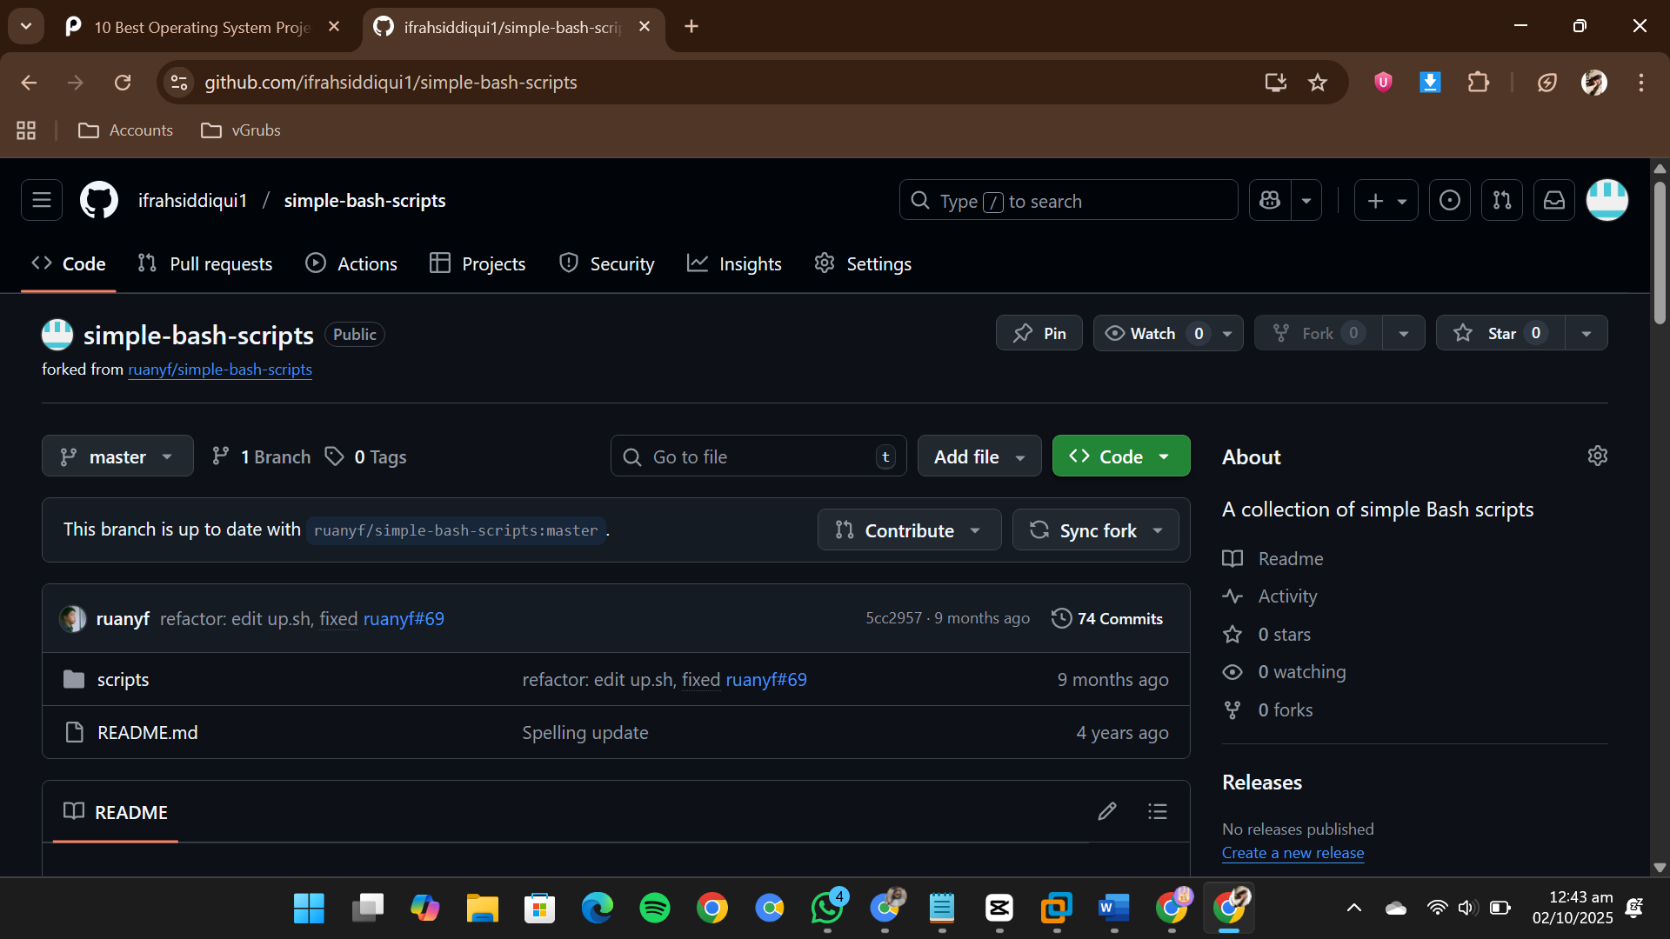

* I use Kali Linux to explore these scripts. I created a folder for my project.



* I cloned the scripts in my Kali by git clone and link of my copied repo.

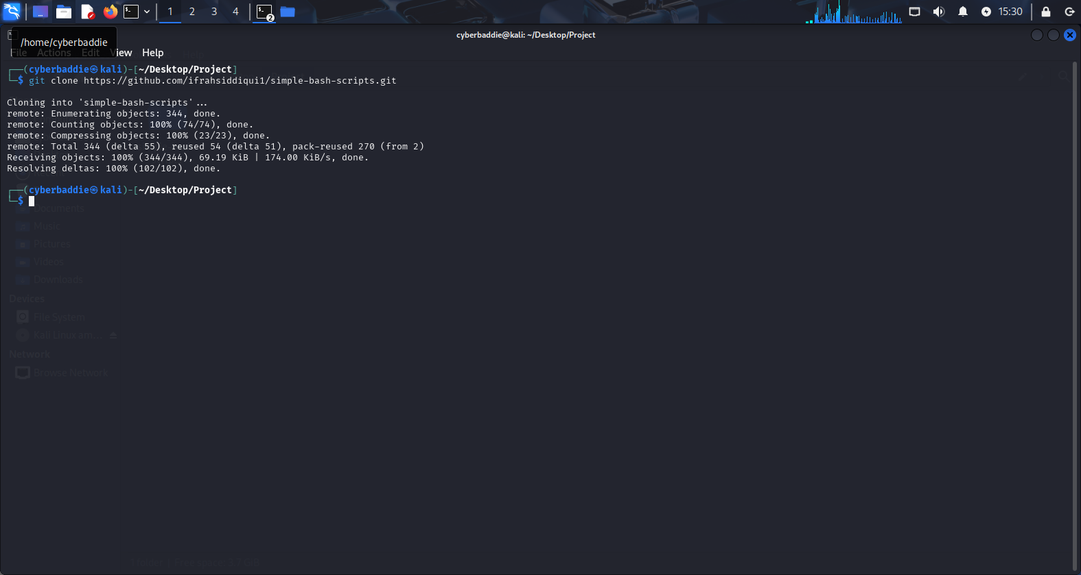

* I checked if it is copied in my kali directory by command ls.

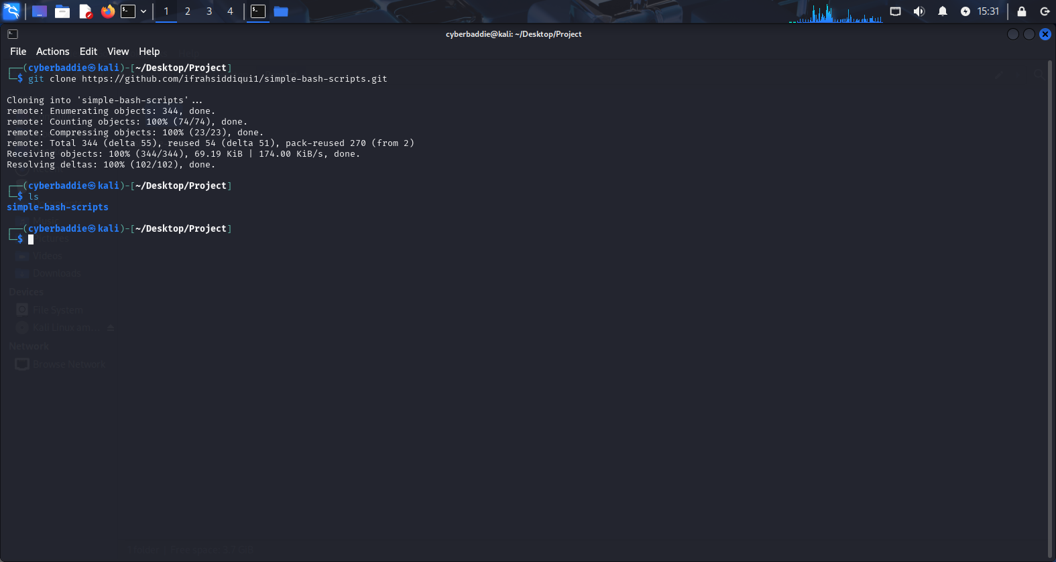

* I again did ls to see files of that folder. Then found a scripts folder after listing files of it I found like 50+ executable files .

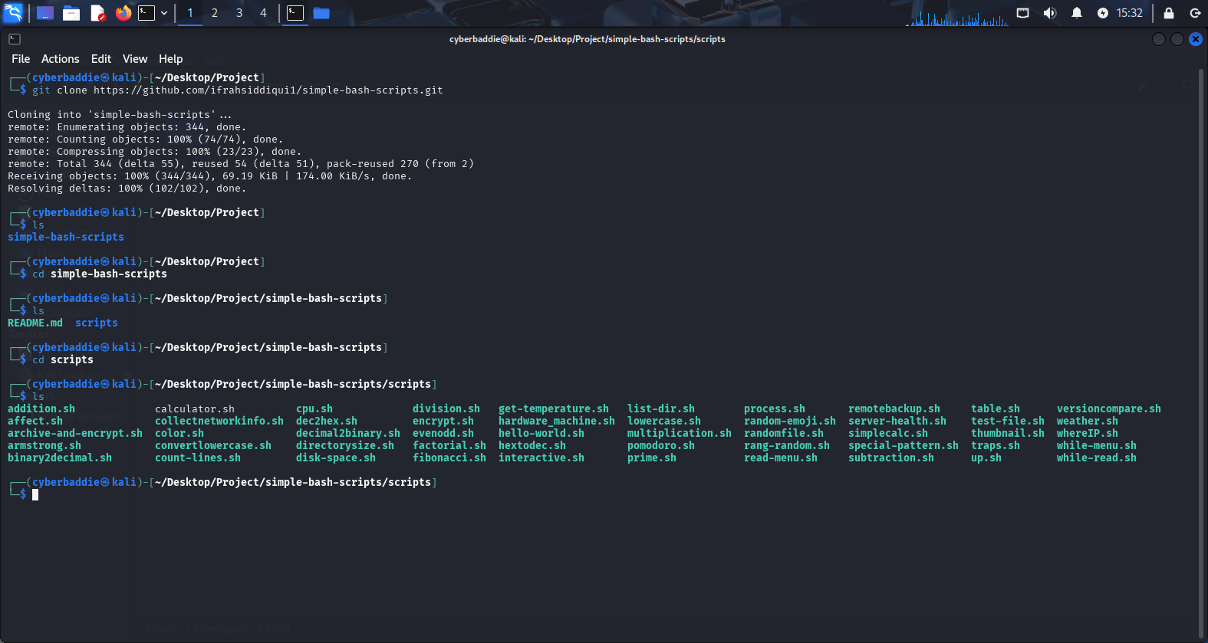

* I tried running some files by using./(their name as listed)
* I run addition.sh file that took two no from me as input and gave output by adding two numbers.

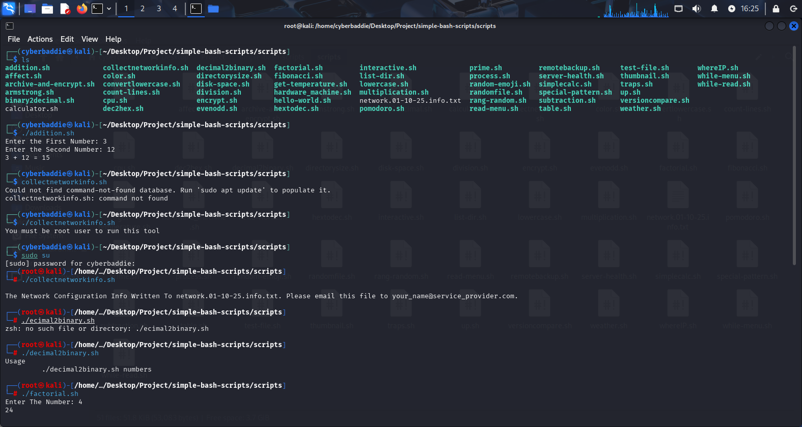

* I runcollectnetwrokinfo.sh file it ask me to run it as a root use I use sudo su entered my password and then run it stores network info in a txt file .



* I opened that file by using cat then filename .

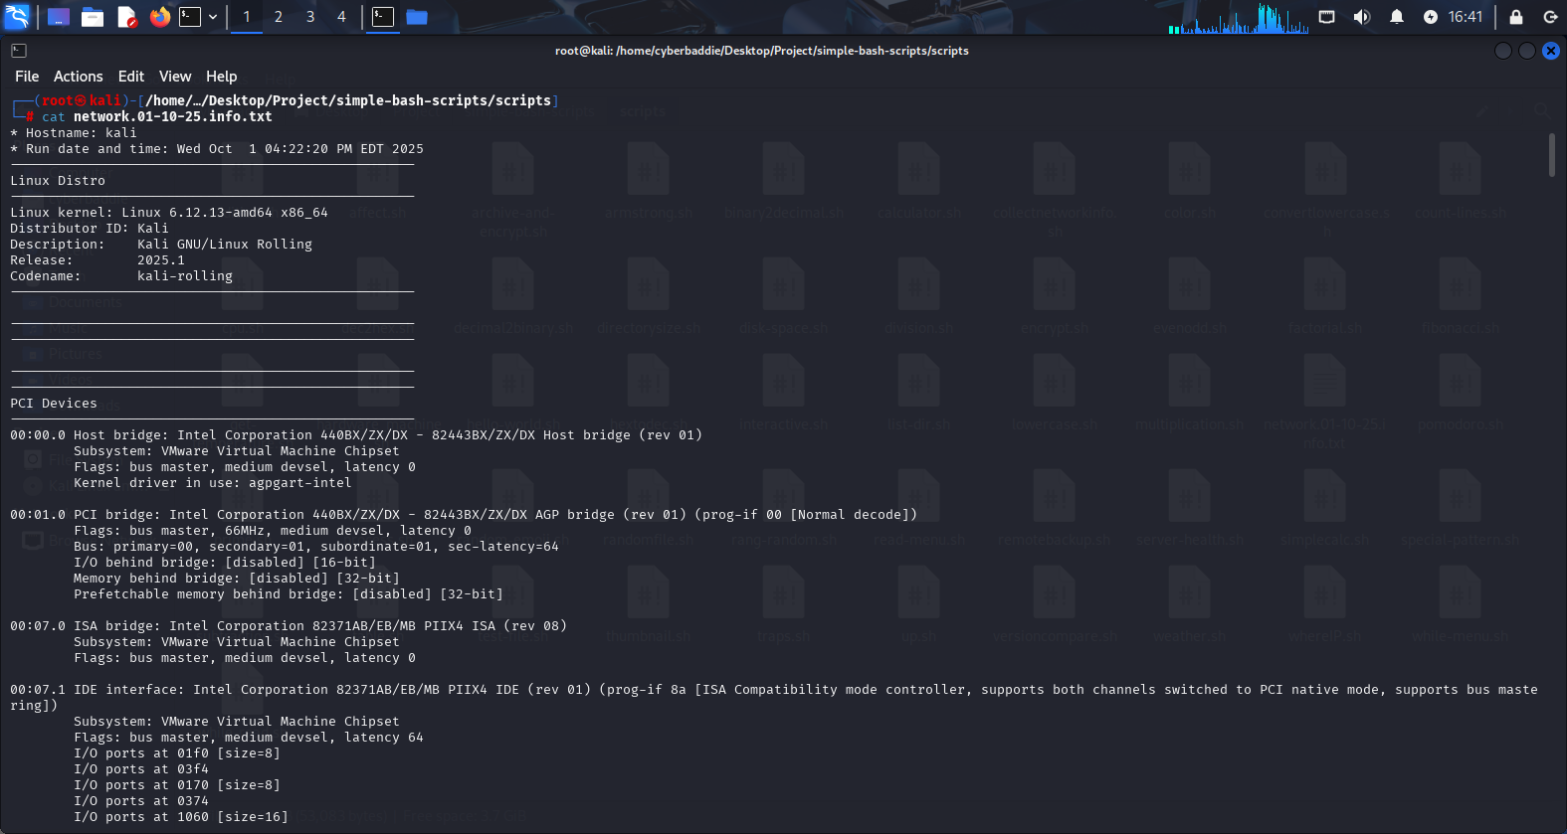

* I run factorial program and it gimme factorial of 3 , when I entered it.

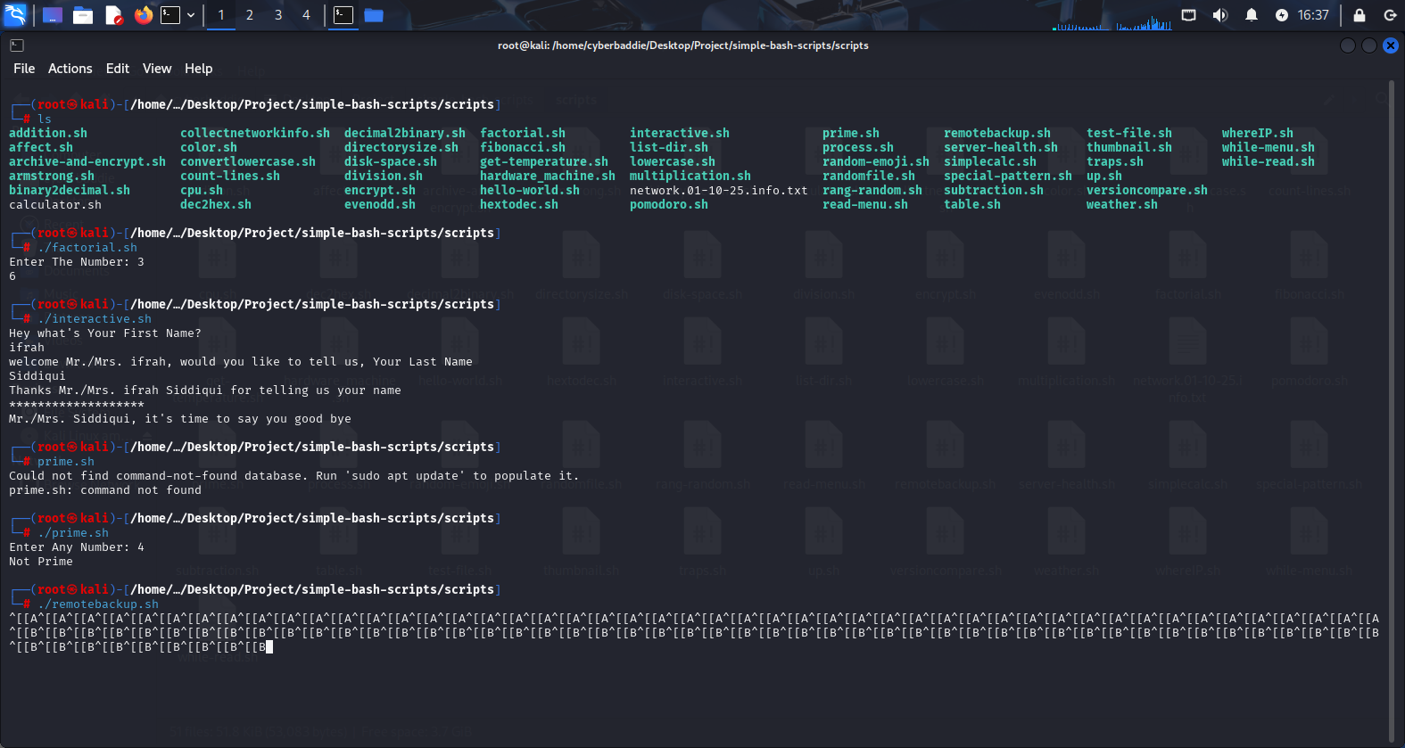

* I run interactive.sh and It ask me for my name and said me good bye , allowing interaction with program.



* I run hellowworld.sh and it said Hello World

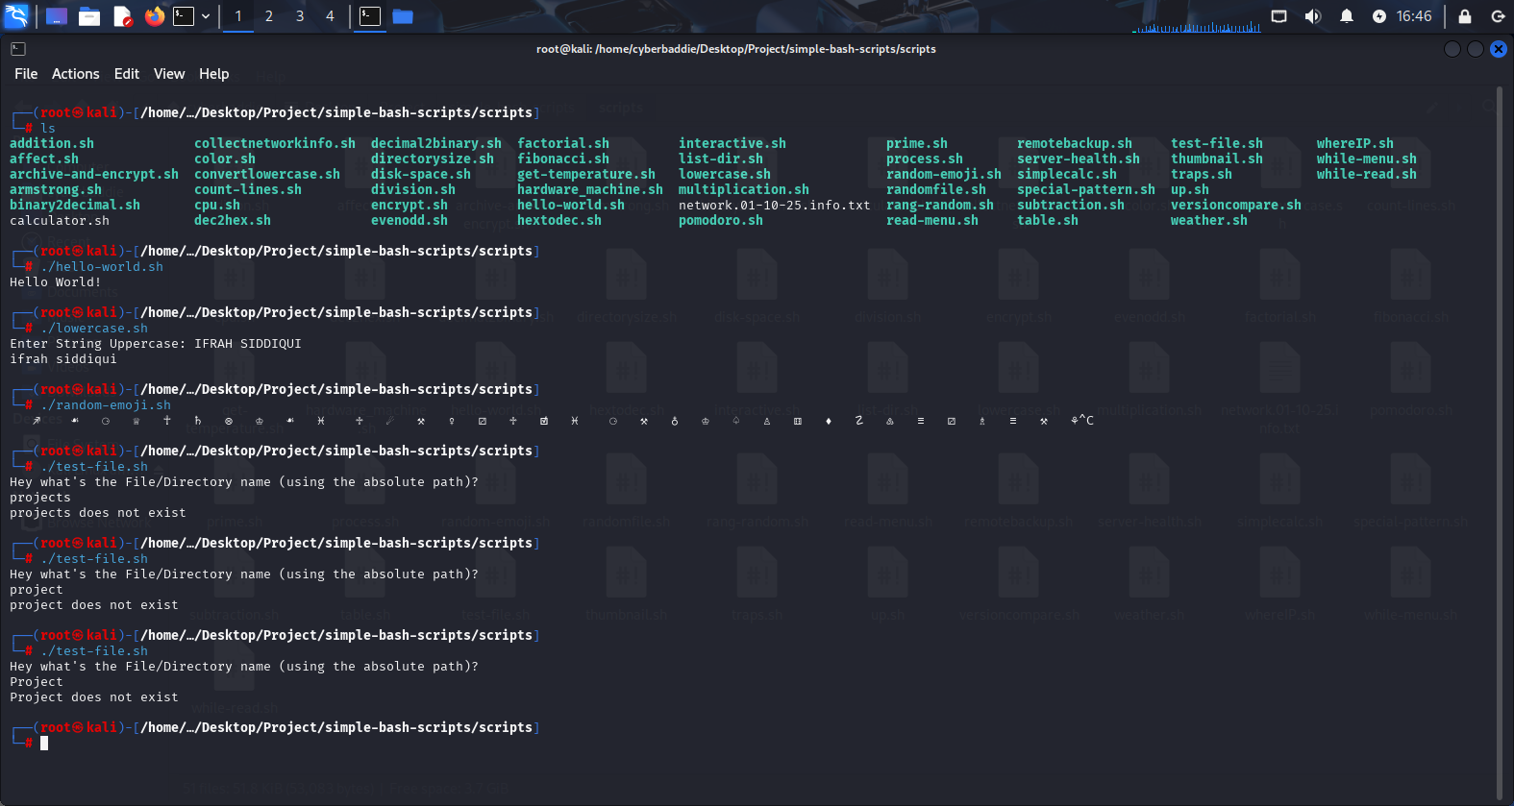

* I run lowercase.sh and It ask me for uppercase letters and converted them into lower case words.

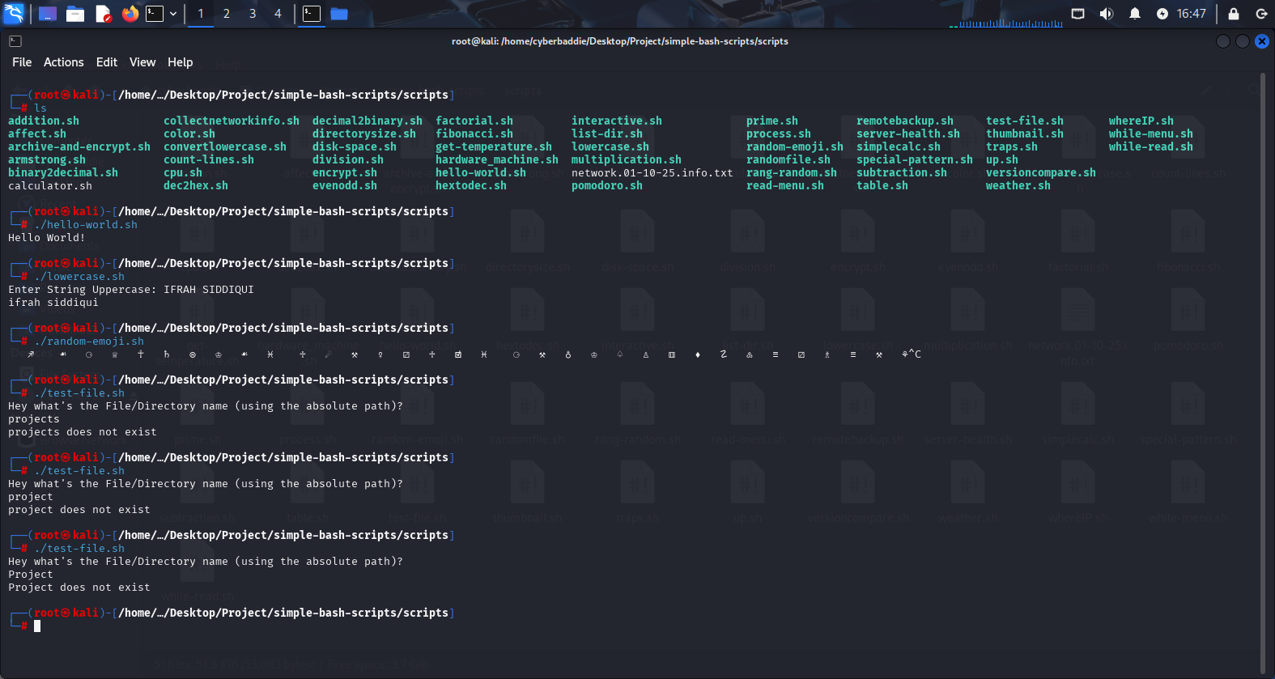

* I run randomemoji.sh and it showed me emoji

